PROJECT 10

TITLE: TRAFFIC MANAGEMENT SYSTEM

PROBLEM STATEMENT:

The project involves using IoT devices and data analytics to monitor traffic flow and congestion in real-time, providing commuters with access to this information through a public platform or mobile apps. The objective is to help commuters make informed decisions about their routes and alleviate traffic congestion. This project includes defining objectives, designing the IoT traffic monitoring system, developing the traffic information platform, and integrating them using IoT technology and Python.

PROBLEM DEFINITION:

Urban and sub-urban areas around the world are facing increasingly congested road networks, which result in traffic congestion, longer commute times, increased pollution, and higher accident rates. To address these challenges and improve the overall transportation experience, there is a pressing need for an advanced Traffic Management System (TMS).

The primary goal of this TMS is to efficiently manage and optimize traffic flow, enhance safety for all road users, reduce congestion, and minimize environmental impacts

WHAT IS TRAFFIC MANAGEMENT SYSTEM:

* A traffic management system is like a maestro orchestrating the movement of vehicles on the roads. It involves a combination of hardware and software solutions to monitor, control, and optimize traffic flow.
* At its core, it includes things like traffic lights, road signs, and signals, but modern systems often incorporate advanced technologies. These can include traffic cameras, sensors embedded in roads, and communication systems that enable real-time data exchange.
* The goal is to enhance traffic efficiency, reduce congestion, and improve overall road safety. Imagine it as a sophisticated dance where the traffic lights are the choreographers, and the vehicles follow the steps to keep everything moving smoothly.

PROBLEM SOLUTION:

The proposed Traffic Management System should leverage emerging technologies like artificial intelligence, Internet of Things (IoT), and data analytics to monitor, analyse and respond to traffic conditions in real time. Additionally, it should prioritize collaboration between government agencies, law enforcement, transportation authorities, and private sector stakeholders to ensure the successful implementation of the system.

The successful development and deployment of this Traffic Management System will lead to improved traffic flow, reduced congestion, enhanced safety, and a more sustainable and efficient transportation network for urban and sub-urban communities.

**DESIGN THINKING:**

PROJECT OBJECTIVES:

* ***Real-time Traffic Monitoring***: Implement a network of IoT devices to collect and transmit real-time data on traffic conditions. Ensure the system continuously monitors key parameters such as vehicle density, speed, and congestion levels.
* ***Congestion Detection:*** Develop advanced data analytics algorithms using Python to process incoming traffic data. Implement real-time congestion detection mechanisms that identify and alert users and authorities to congestion hotspots.
* ***Route Optimization******:*** Integrate machine learning models into the system for predictive analysis of traffic patterns. Provide commuters with personalized route recommendations based on historical and real-time traffic data to optimize travel times.
* ***Improved Commuting Experience:*** Design a user-friendly platform accessible through web and mobile applications. Enhance the platform with intuitive interfaces, real-time updates, and personalized features to empower commuters in making informed decisions.
* ***Data-driven Decision Support:*** Enable traffic management authorities to access comprehensive analytics and reports for informed decision-making. Provide tools and insights to plan and implement measures that alleviate congestion and enhance overall traffic management.

*FLOW CHART:*

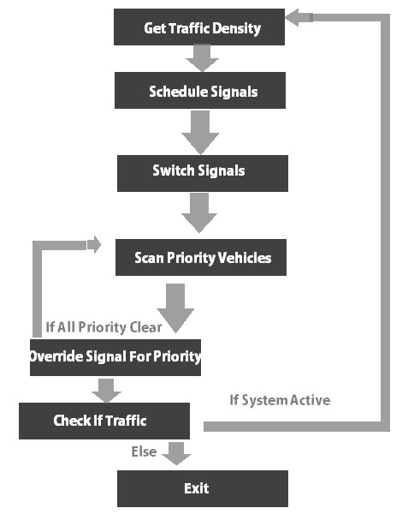

*SYSTEM DESIGN:*

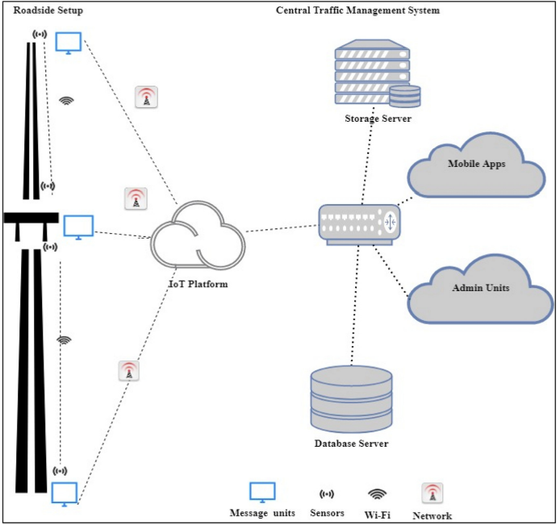

**Designing a web-based platform and mobile apps to display real-time traffic information to the public**

Web-Based Platform:

*1. User Interface:*

Interactive Map: Display a map showing real-time traffic conditions, including congestion, accidents, and construction zones.

Customizable Layers: Allow users to toggle between different layers like traffic flow, incidents, and road closures.

Search Functionality: Implement a search bar for users to find specific locations and routes.

Filter Options: Enable filters for users to refine information based on criteria like time, severity, or type of incident.

Traffic Predictions: Provide predictive analytics showing expected traffic conditions based on historical data and current trends.

Homepage: Clean and intuitive interface displaying an overview of current traffic conditions. Map with color-coded indicators for congestion levels. Quick links to popular routes and areas.

*2. Alerts and Notifications:*

Push Notifications: Allow users to subscribe to push notifications for specific routes or areas of interest.

Email Alerts: Provide an option for users to receive email alerts about major incidents or planned roadworks on their selected routes.

Personalized Alerts: Let users customize alert settings based on their preferences.

Search: Search bar for users to input their location or destination and get real-time traffic information for that route.Integration with navigation services to provide alternate routes based on current traffic conditions.

*3. Additional Features:*

Weather Integration: Integrate weather data to inform users about how weather conditions might affect traffic.

Public Transportation Information: Include real-time data for public transportation schedules, delays, and routes.

Community Reporting: Allow users to report incidents or road issues, contributing to real-time data accuracy.

Social Media Integration: Enable users to share traffic updates on social media platforms directly from the web platform.

Feedback and Reporting: Feedback form to gather user opinions on the accuracy of information.

Community Forum: Discussion forum for users to share tips, discuss traffic conditions, and suggest improvements.

*4. Backend Infrastructure:*

Data Processing: Implement a robust backend system to process real-time data from various sources, ensuring accuracy and reliability.

Data Storage: Store historical and real-time data securely, ensuring quick access and retrieval.

APIs: Create APIs to communicate between the front-end and back-end systems, facilitating real-time data updates.

User Accounts: Optional user accounts for personalized settings and saved routes. History of previously viewed routes and personalized alerts.

Mobile-Based Platform:

*1. User Interface:*

Map Interface: Offer a map interface similar to the web platform, optimized for mobile devices.

User Location: Utilize GPS to show users their current location on the map.

Route Planning: Allow users to input their destination and receive real-time traffic updates for their planned route.

Offline Access: Provide limited offline functionality, allowing users to access basic traffic information even without an internet connection.

Dashboard: Similar to the web homepage, providing a quick overview of traffic conditions. Integration with device GPS to show the user's current location.

*2. Alerts and Notifications:*

Push Notifications: Allow users to subscribe to push notifications for specific routes or areas of interest.

Email Alerts: Provide an option for users to receive email alerts about major incidents or planned roadworks on their selected routes.

Personalized Alerts: Let users customize alert settings based on their preferences.

*3. Additional Features:*

Voice Navigation: Integrate voice-guided navigation to help users navigate around traffic incidents.

Augmented Reality: Implement AR features to overlay real-time traffic information on the phone's camera feed, aiding users in understanding road conditions visually.

Parking Information: Include real-time parking availability and pricing information for users looking for parking spots.

Gamification: Add gamified elements to encourage users to report incidents or share updates, contributing to the community.

Offline Mode: Capability to download maps and traffic data for offline use in case of poor network connectivity.

*4. Security and Performance:*

Secure Authentication: Implement secure authentication methods to protect user accounts and personal data.

Performance Optimization: Ensure smooth performance even with a large number of users accessing the app simultaneously.

Regular Updates: Provide regular updates to fix bugs, improve performance, and add new features based on user feedback.

Integration with Car Systems: Compatibility with in-car systems for a seamless transition between mobile and car navigation.

*5. Marketing and Outreach:*

User Education: Create tutorials and guides within the app to help users make the most of its features.

Social Media: Utilize social media platforms to create awareness about the app's features and benefits.

Accessibility Features: Design with accessibility in mind, including voice commands and screen reader compatibility.

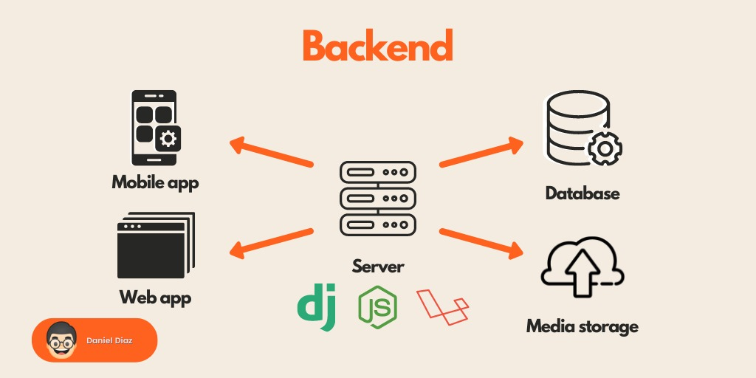

**IOT SENSOR DESIGN:**

*1.Video Image Processor:*  
 A video image processor (VIP) system typically consists of one or more cameras, a microprocessor-based computer for digitizing and processing the imagery, and software for interpreting the images and converting them into traffic flow data.

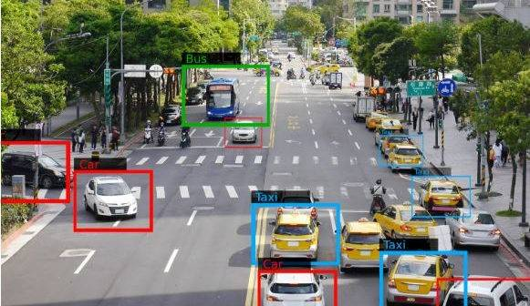

*2.Infrared Sensors:*

Infrared sensors are used for signal control; volume, speed, and class measurement, as well as detecting pedestrians in crosswalks. With infrared sensors, the word detector takes on another meaning, namely the light-sensitive element that converts the reflected or emitted energy into electrical signals. Real-time signal processing is used to analyse the received signals for the presence of a vehicle.

*3.Passive Infrared (PIR):*

Detection of vehicle based on emission or reflection of infrared (electromagnetic radiation of frequency 1011-1014*Hz*) radiation from vehicle surface, as compared to ambient levels emitted or reflected from the road surface. The PIR system collected following parameters: Flow volume, Vehicle presence, and detection zone occupancy. Speed with unit with multiple detection zones

*4.Pulsed and Active Ultrasonic:*

Ultrasonic sensors transmit pressure waves of sound energy at a frequency between 25 and 50 KHz. Pulse waveforms measure distances to the road surface and vehicle surface by detecting the portion of the transmitted energy that is reflected towards the sensor from an area defined by the transmitter’s beam width. When a distance other than that to the background road surface is measured, the sensor interprets that measurement as the presence of a vehicle The received ultrasonic energy is converted into electrical energy that is analysed by signal processing electronics that is either collocated with the transducer or placed in a roadside controller. Vehicles flow and vehicular speed can be calculated by recording the time at which the vehicle crosses each beam.

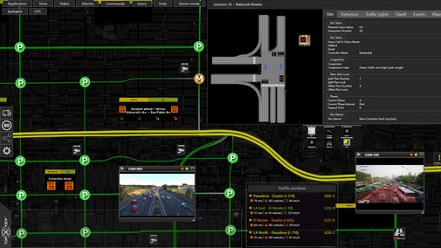

Traffic Congestion is a major issue. Because of this congestion problem, time taken for travelling will be increased. A design was developed using wireless technology with ELB-REV4 is CADA development boards and sensors. An algorithm was also designed so that a greater number of vehicles can pass through a signal. Priorities would be given to different categories of vehicles. Emergency vehicles like ambulances, fire trucks, etc. would have top priority.

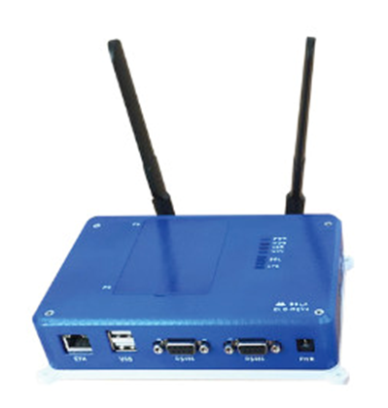

Next is given to VIP's. Next to ordinary vehicles. Priority was also given depending upon vehicle density on one side of the road. The road that has a higher vehicle volume would get highest priority. RFID is mainly used to track the objects. RFID readers and tags are used in showrooms so that no one takes off with any object or material without paying the bill. This RFID is also used to track lost vehicles. When the unique ID of RFID tags of lost vehicles are detected, then their location where they are found is obtained. The green path for emergency vehicles was also designed to provide a green signal so that the ambulance will get the right-of-way. But the disadvantage of this is all vehicles will want to start moving in that open lane, which will create even more traffic for the ambulance.